

MIDDLE EAST TECHNICAL UNIVERSITY

DEPARTMENT OF ELECTRICAL AND ELECTRONICS ENGINEERING

EE-564 PROJECT-3

TRACTION MOTOR DESIGN

Özgür Yazıcı

1937622

**Analytical Design**

Rated output power is 1280 kW. In order to find input current, efficiency is taken as 0.95 and power factor as 0.9.

1280/(0.9*0.95)=1500kVA

1350V*I*(3^0.5)=1500kVA

I=641 Arms

Take 5A/mm^2

641A/5=128.2 mm^2

Pi*r^2=128.2 mm^2

r=6.39mm

For 78 Hz skin dept is 7.38mm so single wire with 12.8 mm diameter can be used.

Pmech/2p=1280/6=213.33 kW/pole

Since we know the watts/pole value, we can chose Cmech value. According to the chart, the value should be between 250 and 300.

Pmech=Cmech*D^2*l*n

n=f/p=78/3=26

1280=Cmech*D^2*l*26

0.197>D^2*l>0.164

After that motor aspect ratio should be determined.

X=l/D

X= pi*(p^(1/3))/(2*p)=pi*(3^(1/3))/(2*3)=0.755

Take D^2*l=0.180 and l/D=0.755

0.180/0.755=D^3

D=0.62m, l=0.47m

Take D=0.6m l=0.5m and B=0.9T

Tp=pi*D/6=pi*0.1

Ф=l*Tp*B*2/pi=l*pi*D/6*0.9*2/pi=90 mWeber

Return back to induced voltage.

E=4.44*f*kw*N* Ф

Vll=1350V

Vph=780V

780=4.44*78*0.95*N*0.090

N=26.34 turns

Number of turns must be an integer. Take N=24. Electrical loading should be calculated for this case.

A=53.721 kA/m

Fort his case, induced voltage shoud be adjusted again for N=24 by changing the dimensions.

780=4.44*78*24* Ф

Ф=93.8mWeber

Keep the diameter same and increase the length to match required flux.

L=0.5m Ф=90 mWeber

L=0.52m Ф=0.93 mWeber

**Analytical Results**

L=0.52 m

D=0.6 m

A=51 kA/m

X=0.867

I=641A

**RMxprt Design**

By using analytical calculations, machine dimentions are determined. In this part by using Ansys Maxwell, machine is simulated.

Rmxpert drawing of the motor is given in figure 1.

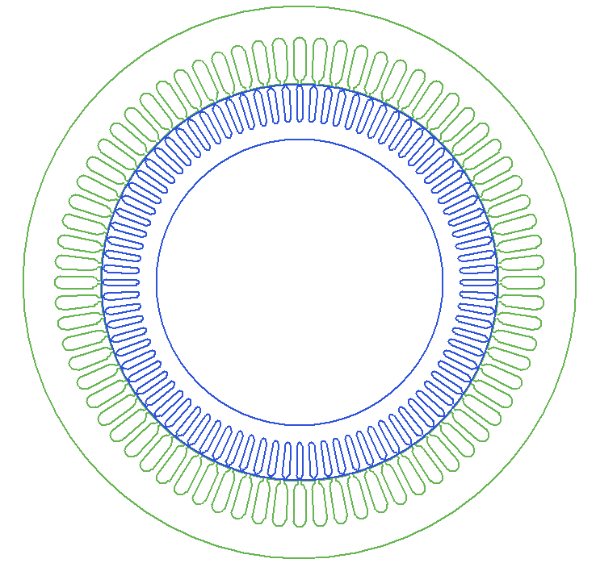

Figure 1 Rmxpert drawing

Output power vs torque graph is given in figure 2.

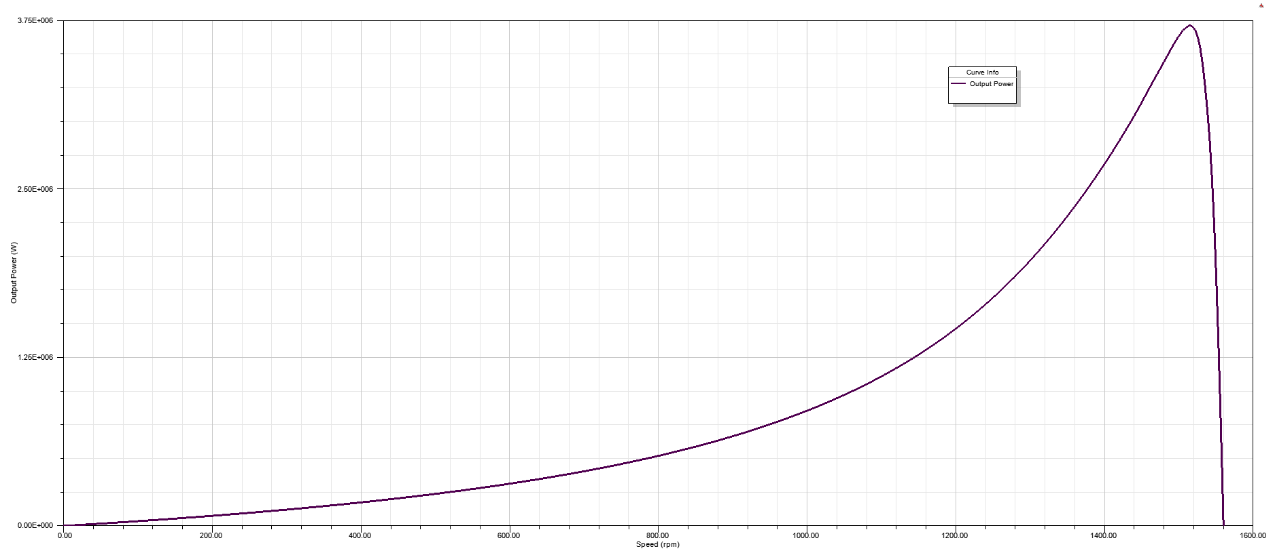

Figure 2 Output power vs speed

Output torque vs speed graph is given in figure 3.

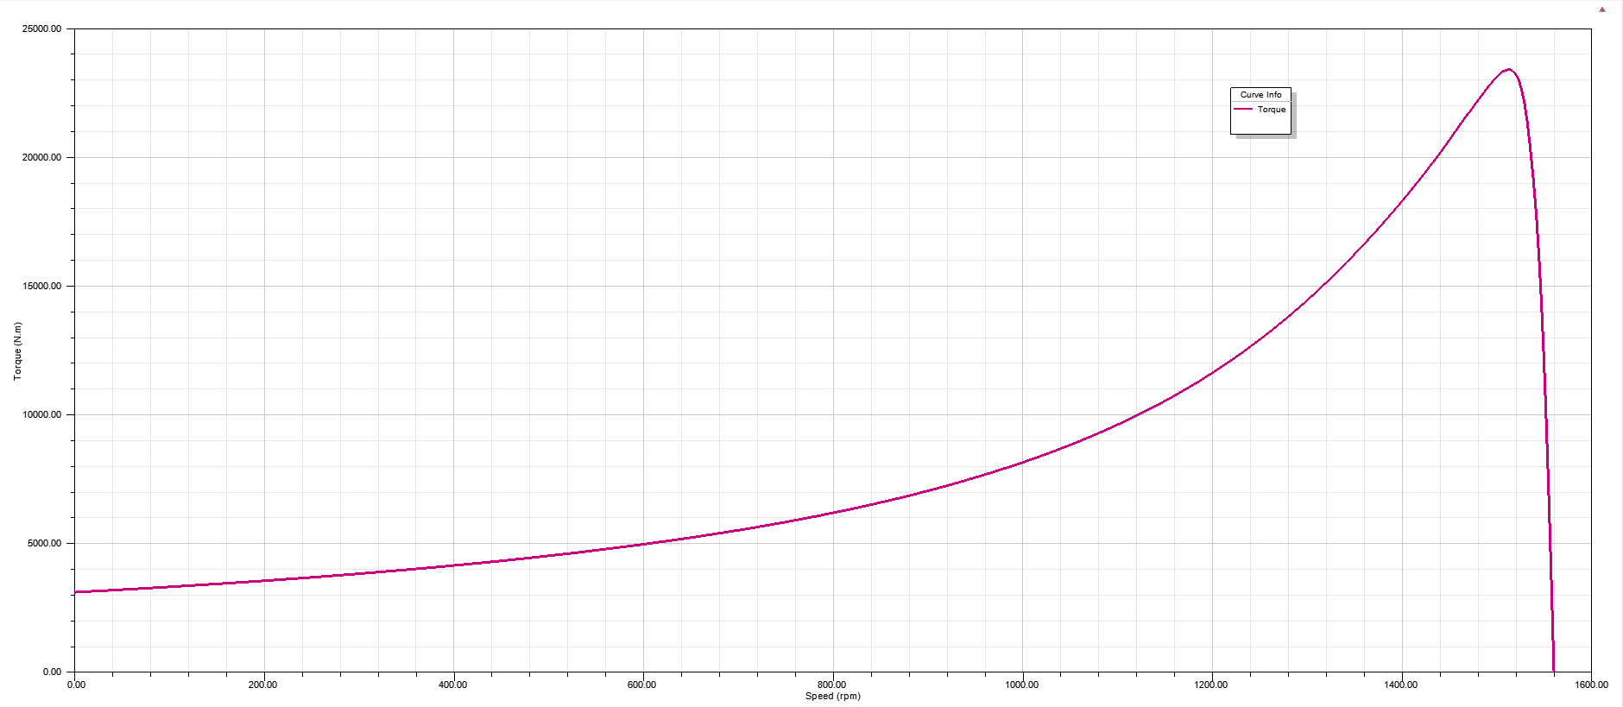

Figure 3 Output torque vs speed

Efficiency vs output power graph is given in figure 4. It can be seen that, the efficiency reaches 95.5%.

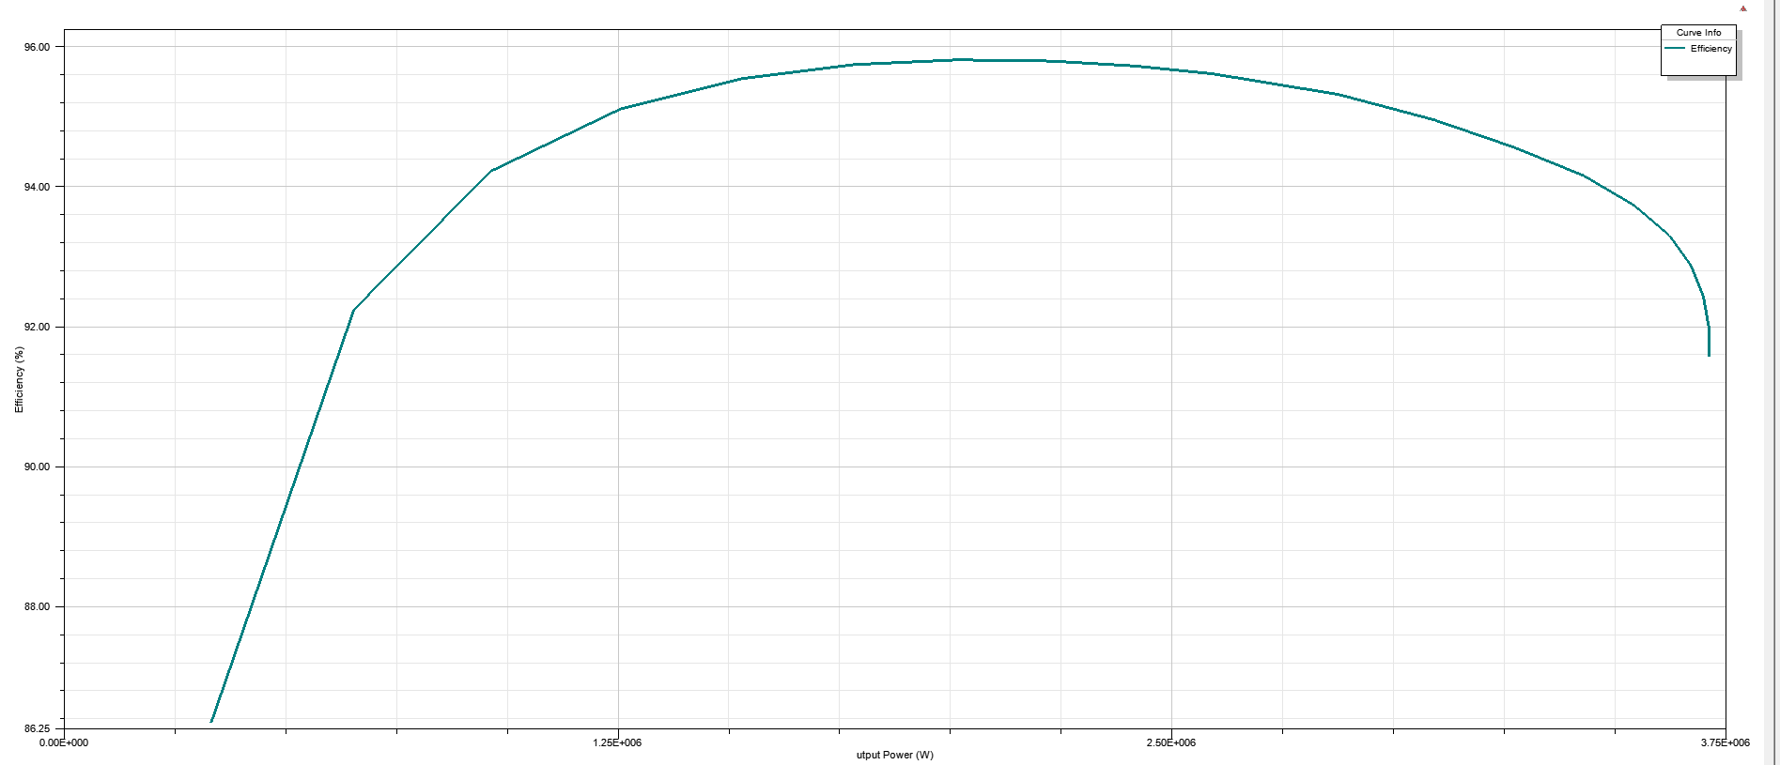

Figure 4 Efficiency vs output power

Winding diagram can be seen in the figure 5.

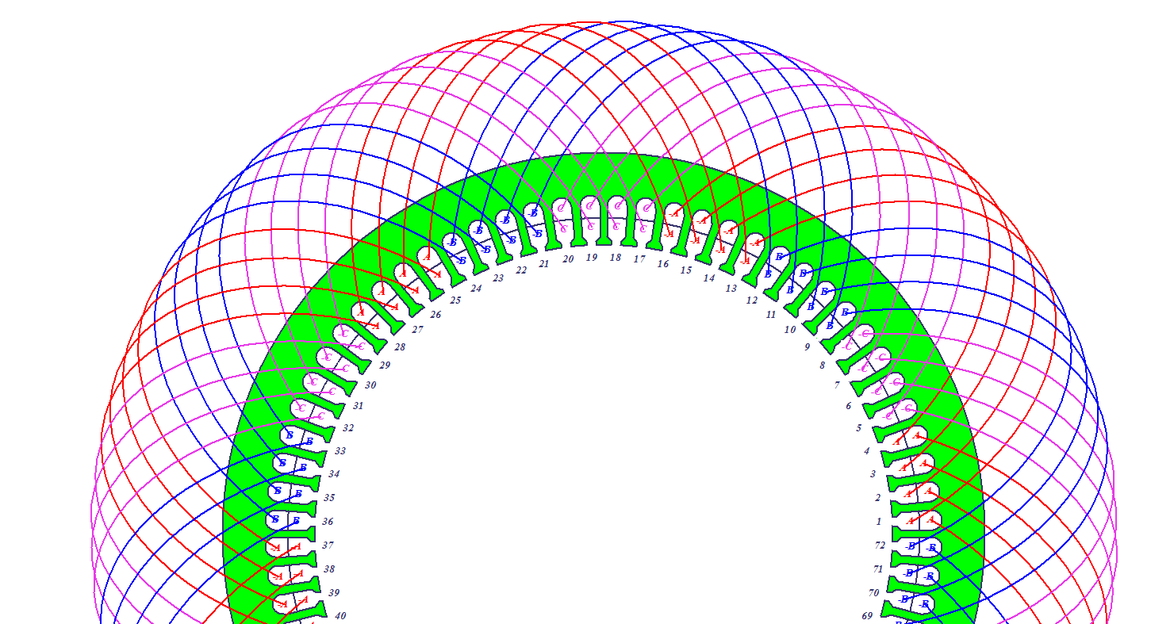

Figure 5 Winding diagram

In order to prevent the silicon steel from saturating, flux densities are kept small. By this way, core losses are smaller. In larger motors since the cooling area over volume ratio is smaller, overheating is a serious issue. Because of that flux densities are small in this design. If the application would require a smaller or lighter motor, higher flux densities could be preferred.

Stator-Teeth Flux Density (Tesla): 1.39474

Rotor-Teeth Flux Density (Tesla): 1.21896

Stator-Yoke Flux Density (Tesla): 1.12774

Rotor-Yoke Flux Density (Tesla): 0.237104

Armature Copper Weight (kg): 197.124

Rotor Bar Material Weight (kg): 616.406

Rotor Ring Material Weight (kg): 21.6967

Armature Core Steel Weight (kg): 1879.78

Rotor Core Steel Weight (kg): 969.792

Total Net Weight (kg): 3684.8

Figure 6 shows stator slot dimensions.

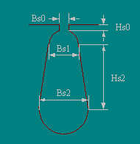 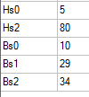

Figure 6 Stator slot

**2D Design**

After RMxprt design, the machine is also simulated by 2D fea tool. Again Ansys Maxwell is used.

Figure 7 shows flux density of the machine while it is operating in rated conditions.

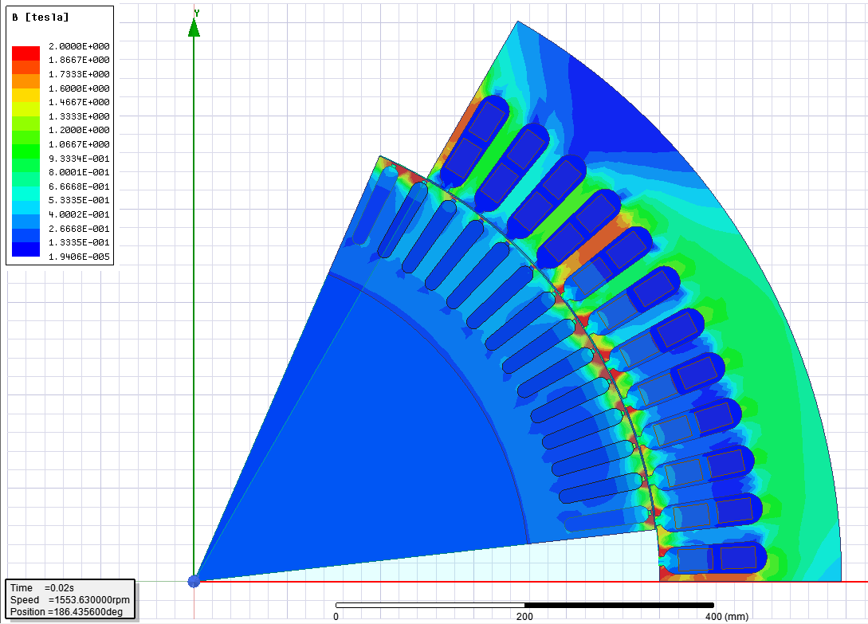

Figure 7